1. 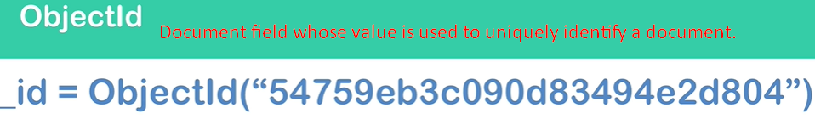
2. MongoDB uses a special BSON Data Type for _id which is ObjectId and this field is used to uniquely identify a document.
3. ObjectId is 12-byte length value which is created automatically by MongoDB. This is performed when we insert a new document into a collection.
4. **How this unique ID is generated**?
5. Actually, it is consisting **of 4 parts**.  
   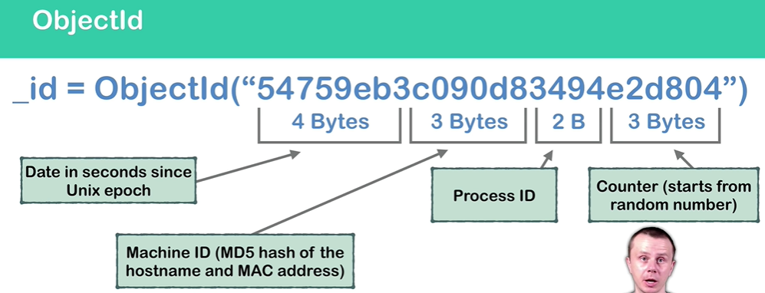
   1. **First 4 Bytes**: Represents date in seconds from Unix epoch.
   2. **Next 3 Bytes:** It’s special MD5 hash that is generated using hostname and MAC address (it is hardware address) of the server where MongoDB runs.
   3. **Next 2 Bytes:** Process Id of mongo itself.
   4. **Next 3 Bytes:** Counter that starts from a random number and for each next document insertion, it is incremented.
6. Let’s see this in action.
7. **NOTE**:
   1. One Hex = 4 Bits
   2. Two Hex = 8 bits = 1 byte
   3. Multiply it by 12
   4. So, 24 Hex = 96 bits = 12 bytes.
8. **NOTE**: ObjectId is also of length 12 bytes.
9. 